
Project Executable Files
Date | 07 July 2026
Team ID | SWTID-2026-6913
Project Name | Opticrop:Smart Agricultural Production Optimization Engine
Maximum Marks | 3 Marks

Project Executable Files
This section requires submission of all executable and deployable files for your project. Ensure all files are properly organized, named, and uploaded to the specified submission platform. The evaluator must be able to run or deploy your solution using the provided files and instructions.
Step 1: Submission Checklist
S.No | Item to Submit | Submitted (Yes / No / NA)
1 | Complete source code (all files and folders) | yes
2 | README / Setup Guide (instructions to run the project) | yes
3 | requirements.txt / package.json / dependency file | yes
4 | Database schema / seed files (if applicable) | no
5 | Environment configuration file (.env.example or similar) | no
6 | Deployed application URL (if hosted) | yes
7 | APK / Executable binary (if applicable for mobile/desktop apps) | yes
8  9  10 | Dockerfile / Containerization config (if applicable) Test files and test results  Demo video or walkthrough (if required) | yes



Step 2: File / Folder Structure
Provide an overview of your project's file and folder structure below:
OptiCrop/
│
├── app.py
├── requirements.txt
├── README.md
│
├── Data/
│ └── Crop_Recommendation.csv
│
├── Models/
├── crop_model.joblib
├── scaler.joblib
└── train.py
│
├── Templates/
│ └── index.html
│
├── static/
├── style.css
└── script.js
│
└── notebook.ipynb

Step 3: Deployment / Access Details
Field | Details
Hosted / Deployed URL | https://github.com/LakshmiLavanyasaladi/Lakshmilavanyasaladi-Opticrop-Smart-Agriculture-Production-Optimization-Engine
Login Credentials (Demo) | [Provide demo username and password for evaluator access]
Platform / Hosting Provider | [e.g., Render, Vercel, AWS, Heroku, Azure]
Repository Link | https://github.com/LakshmiLavanyasaladi

Demo Video Link: https://drive.google.com/file/d/1J32-EeO4flfudTgnrRR68dtd49mlVHUE/view?usp=sharing

Step 4: Run Instructions
Provide clear, step-by-step instructions for the evaluator to run your project locally:follow as given below.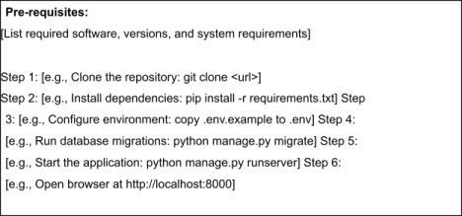
Step 5: Known Issues / Limitations
S.No | Known Issue / Limitation | Workaround / Status
1 | The model predicts only crops available in the training dataset. | Use a larger and updated agricultural dataset to support more crop varieties.
2 | Prediction accuracy depends on correct user input (N, P, K, pH, temperature, humidity, rainfall). | Validate user inputs and display error messages for invalid values.
3 | The application works only on a local server (http://127.0.0.1:5000) and is not deployed online. | Future enhancement: Deploy the application on Render, Railway, or another cloud platform for public access.

